**Design Pattern and Principle**

**Exercise 1: Implementing the Singleton Pattern**

**Logger.java**

package SingletonPatternExample;

public class Logger {

private static Logger *Instance*;

private Logger() {

System.*out*.println("Logger is Initialized");

}

public static Logger getInstance() {

if(*Instance*==null) {

*Instance*=new Logger();

}

return *Instance*;

}

}

**Main.java**

package SingletonPatternExample;

public class main {

public static void main(String[] args) {

Logger log1=Logger.*getInstance*();

Logger log2=Logger.*getInstance*();

if(log1==log2) {

System.*out*.println("Only one Logger is created");

}

else {

System.*out*.println("singleton failed");

}

}

}

**Output**

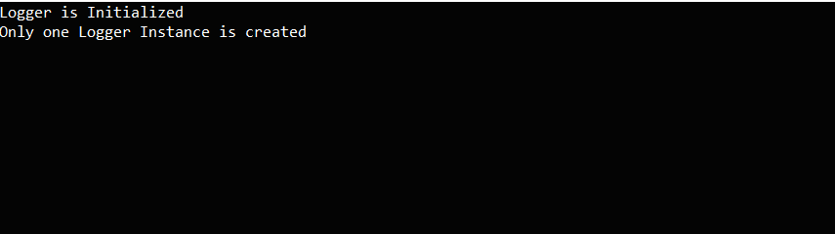

**Exercise 2: Implementing the Factory Method Pattern**

**Document.java**

package FactoryMethodPatternExamplee;

interface Document {

void doc();

}

**ExcelDocument.java**

package FactoryMethodPatternExamplee;

public class ExcelDocument implements Document {

public void doc() {

System.*out*.println("It is ExcelDocument");

}

}

**PdfDocument.java**

package FactoryMethodPatternExamplee;

public class PdfDocument implements Document {

public void doc() {

System.*out*.println("It is PdfDocument");

}

}

**WordDocument.java**

package FactoryMethodPatternExamplee;

public class WordDocument implements Document{

public void doc() {

System.*out*.println("It is a WordDocument");

}

}

**DocumentFactory.java**

package FactoryMethodPatternExamplee;

public abstract class DocumentFactory {

public abstract Document createDocument();

}

**ExcelDocumentFactory.java**

package FactoryMethodPatternExamplee;

public class ExcelDocumentFactory extends DocumentFactory{

public Document createDocument() {

return new ExcelDocument();

}

}

**PdfDocumentFactory.java**

package FactoryMethodPatternExamplee;

public class PdfDocumentFactory extends DocumentFactory{

public Document createDocument() {

return new PdfDocument();

}

}

**WordDocumentFactory.java**

package FactoryMethodPatternExamplee;

public class WordDocumentFactory extends DocumentFactory {

public Document createDocument() {

return new WordDocument();

}

}

**Main.java**

package FactoryMethodPatternExamplee;

public class main {

public static void main(String[] args) {

DocumentFactory word=new WordDocumentFactory();

Document w1=word.createDocument();

w1.doc();

DocumentFactory pdf=new PdfDocumentFactory();

Document p1=pdf.createDocument();

p1.doc();

DocumentFactory excel=new ExcelDocumentFactory();

Document e1=excel.createDocument();

e1.doc();

}

}

**Output**

